Download LSS Flowarm from :

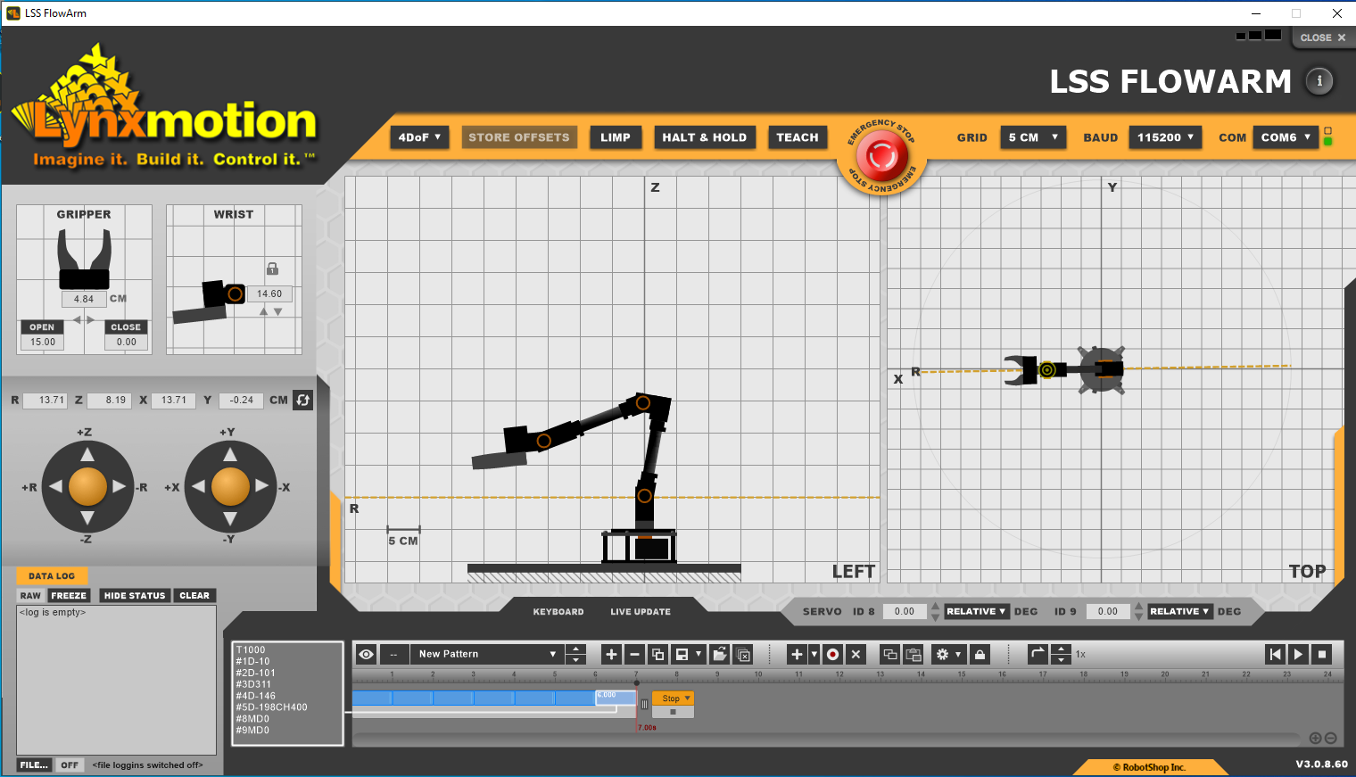

4

3

2

1

Ensure USB is connected and the items are set as in the red circle above (your COM number may differ). Ensure 4Dof is selected above.

To teach the robot a position either:

1. Click and drag the joints to the position in the side and top view
2. Use the virtual joysticks to move the end point coordinates (green circle)
3. Make the arm go limp and manually move to a position (see below)

**Then Press the record button ‘2’.**

Manually move to a position

Support the arm

Press the ‘TEACH’ button (see ‘1’ above)

Manually move the position (including the wrist pitch and the gripper open/close value). Ensure the virtual arm on the screen ‘catches up’ (can be laggy)

Teaching a sequence of movements

A

9

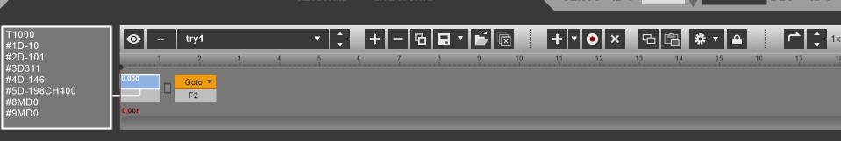

8

6

7

5

4

These are known as a ‘pattern’.

Press the ‘new pattern’ (+ sign next to ‘3’)

Rename it.

Move the robot to position 1 that you want.

Press the ‘+’ at point ‘4’ above.

This will add it to the list as a blue position ‘5’

You can change the speed of motion by stretching the blue pattern box (stretched wider=slower).

Change the ‘Yellow Goto’ to Stop, this is a method of jumping between patterns.

You can move through motions slowly by dragging the black dot above the patterns.

A movement can be overwritten ‘6’, or deleted ‘7’.

The code sent to the servos can be manually altered ‘8’.

Patterns can be associated with a tag (F1..F10, or letters etc) by selecting point ‘9’. That way, a Goto can then call another pattern.

Patterns can be swapped ‘A’

Info key

Press this key to give info!

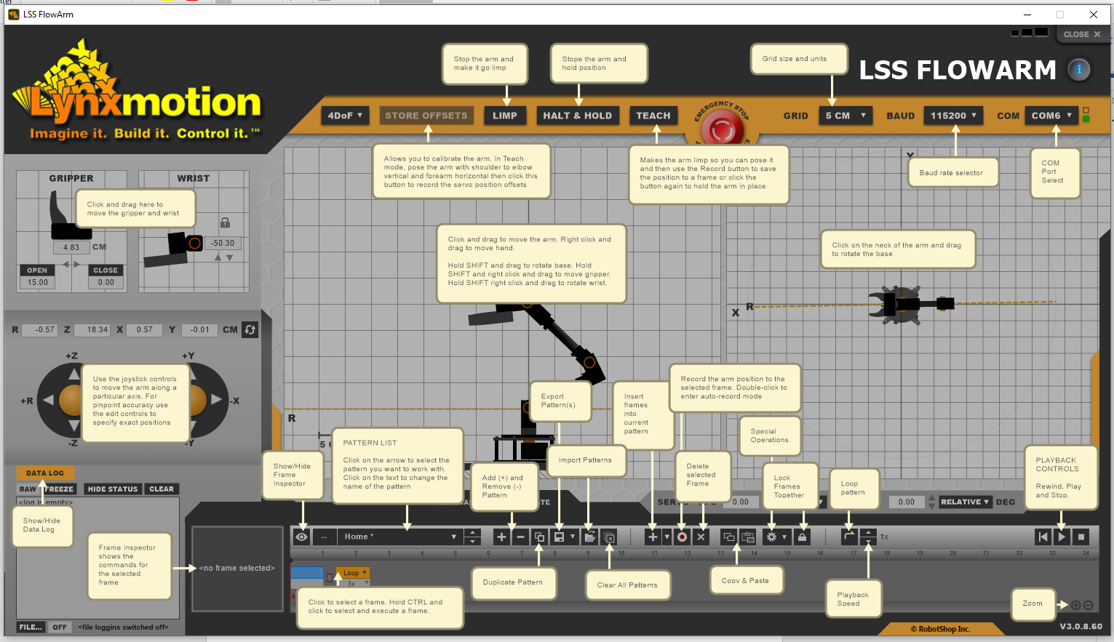

https://www.robotshop.com/info/wiki/lynxmotion/view/servo-erector-set-system/ses-software/lss-flowarm/